What is Forensic Science?
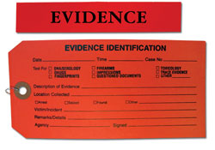
Forensic science is the application of science to the law.
Dating back to the time of the Romans, "forensic" is a Latin word meaning "forum."
Forensic Scientists play a critical role in the justice system by providing scientific information to investigators and the courts.
A forensic scientist must be capable of integrating knowledge and skills in the examination, analysis, interpretation, reporting, and courtroom testimony of scientific evidence. Forensic scientists usually have a strong background in the chemical, biological, or physical sciences.
Although the term "criminalistics" is often used to refer to the science and profession responsible for recognition, collection, identification, individualization, and interpretation of physical evidence and natural science, there are a number of disciplines or focus areas.
Forensic biology usually refers to the analysis of blood and physiological samples, including DNA typing, for the purpose of identification and individualization. Forensic botany, forensic entomology, and forensic anthropology also broadly fall into this category. Forensic anthropology usually refers to the recovery and identification of skeletonized human remains.
Forensic chemistry usually means the use of instrumental and chemical methods to analyze drugs (controlled substances), alcohol, fire and explosive residues, hairs, fibers, glass, soil, paint, and other materials. Forensic toxicology involves the analysis of drugs, poisons, and alcohol in biological samples taken from living or deceased persons.
Forensic science also relies upon physical methods of identification such as fingerprint analysis (fingerprint developing, identification, and comparison), toolmark and firearm identification, forensic document examination, and reconstruction.

