U.S. Political Representation

Republicans
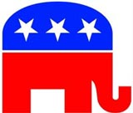

Basic Information
- Conservative (Right)
- “The Grand Old Party” or GOP

Political Platform
- Believe that the federal government should not play a big role in people's lives.
- Limited national government
- More state controlled government
- Typically favor less spending on government programs such as health care
- Favor lower taxes
- Less government intervention in business and the economy.
- Pro-life
- Support the 2nd Amendment
(The right to bear arms)

Democrats
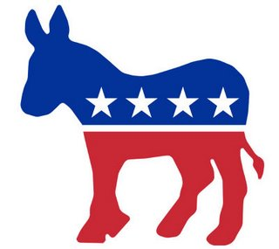

Basic Information
- Liberal (Left)
- “The Party of the People”
- Attracts immigrants, blue-collar workers, women, and minorities.
Political Platform
- Believe that the federal government should take a more active role in people's lives, particularly those who are in need.
- Larger government
- stronger, more centralized (national) government
- Favor more spending on government programs such as health care
- Are for issues that help the working class and the underprivileged.
- Pro-choice
- Pro-gun control

Third Party Groups

Independents
- Voters who are not linked to any political party
- Non-partisan
- Does not lean strongly toward one of the two parties (Democrat/Republican)
- Many believe that the electoral process and government should be reformed

Libertarians
- America’s largest third party
- All individuals have the right to exercise sole dominion over their own lives, and have the right to live in whatever manner they choose, so long as they do not forcibly interfere with the equal right of others to live in whatever manner they choose.

Green Party
- Prides itself on providing real solutions for real problems, and focus on big corporations that are opposed to reform. Believes in the grassroots democracy of social justice and non-violence.

Tea Party
- Calls awareness to any issue that challenges the security, sovereignty, or domestic tranquility of the United States of America.

