Three Forms of Totalitarianism

Communism
Joseph Stalin ruled the Soviet Union from 1922 to 1953. Historians hold him responsible for the deaths of millions of Russians. The hammer in the communist symbol represents industrial workers, while the sickle represents agricultural workers.

Fascism
Benito Mussolini was dictator of Italy from 1922 to 1943. He used his power to control every aspect of the government and the press. This symbol of fascism suggests that while a single stick may be easily broken, a bundle of sticks bound together is too strong to break.

Nazism
While ruling Germany from 1933 to 1945, Adolf Hitler tried to rid Europe of Jews, Gypsies, and others he deemed “undesirable.” The swastika is an ancient Hindu symbol of well-being. The Nazis adopted it as a symbol of the German master race.

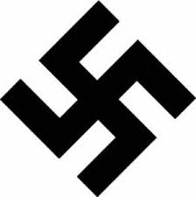

Key Characteristics
- The Communist Party holds supreme power

- Belief that the state should control the economy

- Brutal suppression of opposition

- Hostility to religion and human rights

Key Characteristics
- Dictator holds supreme power

- Belief that everyone should serve the state

- Extreme nationalism

- Glorification of the military

- Use of censorship and terror to suppress opposition

Key Characteristics
- The Nazi Party holds supreme power

- Belief in racial superiority

- Aggressive territorial expansion

- Elimination of “inferior” minorities

- Rejection of democracy and civil liberties

