Solving Crimes with Forensics

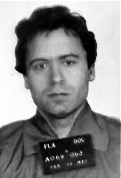
- Ted Bundy
Although serial killer Ted Bundy was responsible for an estimated 30-plus murders, there was little physical evidence to connect him to the crimes when he was arrested in 1975. Two years later, having been convicted only of kidnapping, Bundy was preparing to stand trial for murder in Colorado when he escaped and headed to Florida. There, he killed three more people early in 1978, and when he was finally captured in February of that year, the physical evidence in those cases led to his conviction. Most crucial was the matching of a bite mark on the buttock of victim Lisa Levy to the Bundy's distinctive, crooked and chipped teeth. He was convicted also of the murder of 12-year-old Kimberly Leach based on fibers found in his van that matched the girl's clothing. Bundy was put to death in 1989.

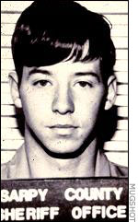
- John Joubert
In 1983, two murders of schoolboys rocked the Omaha, Nebraska area. The body of one of the boys was found tied with a type of rope that investigators couldn't identify. While following up on the lead of a mysterious man scouting out a school, they traced the suspect's license plate to John Joubert, a radar technician at the local Air Force base. In his belongings, they found a rope matching the unusual one used in the murder (which turned out to be Korean). Although DNA analysis technology was not yet an option, the extreme rarity of the rope was enough to lead to Joubert's confession. Furthermore, hair from one of the victims was found in Joubert's car. The child killer was even linked to a third murder, in Maine, when his teeth were found to match bite marks on a boy killed in 1982. Joubert was found guilty of all three murders and was put to death in the electric chair in 1996.

Directions – Answer the following questions in complete sentences on a separate sheet of paper for each person and turn in for a grade. Question 4 might not be able to be answered for all scenarios. If unable to answer, use (N/A) for your answer to #4.

Questions
- Who was the criminal?
- What was the crime(s)
- When and Where did the crime(s) take place?
- Is there any background information known about the criminal to possibly explain their actions?
  - i.e. childhood experiences / previous convictions
- How were forensics used to help solve the crime?
- What happened to the criminal?

