Did Jefferson Davis Approve the Lincoln Assassination Conspiracy?
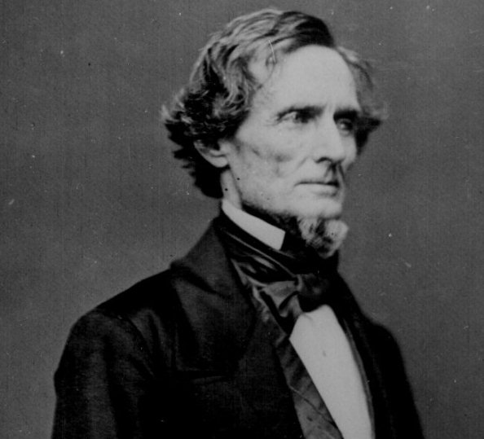

1. Jefferson Davis appointed two men (Jacob Thompson and Clement Clay) to head the Confederate Secret Service in February 1864.
----$5 million appropriated by Confederate Congress to fund CSS
----Operations based largely in Canada

2. The Confederate Secret Service planned or engaged in numerous acts of terrorism or biological warfare.
---Raid on St. Alban's, Vermont
---Fires started in New York City hotels (Election Day plot of 1864)
---Plot to poison New York City water supply
---Plot to infect Union soldiers and citizens with smallpox and yellow fever
---Plot to kidnap Lincoln and hold until Confederate soldiers released
---Plot to blow up White House

3. The Lincoln Conspiracy Timeline
---Fall 1864 Booth, Surratt, Powell meet at least twice with CSS in Montreal
---Oct. 13, 1864 Ciphered letter sent from Richmond to Booth: His "friends would be set to work as directed"
---Nov. 1864 John Wilkes Booth begins recruiting for Lincoln kidnap plot
---Nov. 29, 1864 Davis responds to offer to rid Confederacy of its "deadliest enemies"
---Jan. 1865 Conspirator Lewis Powell seen meeting in Montreal with Clement Clay
---Jan. 1865 Jacob Thompson talks of proposition by "group of bold men" to kill Union leaders
---March 27, 1865 John Surratt visits Richmond and meets with Confederate AG and Jefferson Davis
---April 3, 1865 John Surratt leaves Washington, D. C. for Canada
---April 6, 1865 Surratt arrives in Montreal, bringing with him a ciphered letter from Richmond
--------Thompson: "This makes the thing all right"
--------$184,000 withdrawl from Montreal Branch of Ontario Bank
----April 9 General Robert E. Lee surrenders
---April 10, 1865 Montreal justice of peace approached with information of plot to kill Lincoln and others
---April 10, 1865 Confederate explosives expert plotting to blow up White House arrested
---April 14, 1865 Lincoln assassinated and Secretary Seward stabbed
---April 19, 1865 In Charlotte, Davis learns of assassination by telegram
---April 19, 1865 Upon learning of assassination, Davis says: "If it were to be done, it were better it were well done."
---April 21, 1865 Davis says: "if the same had been done to Andy Johnson, the beast, and to Secretary Stanton, the job would then be complete."

4. "Whatever may be the conviction of others, my own conviction is that Jefferson Davis is as clearly proven guilty of this conspiracy, as is John Wilkes Booth, by whose hand Jefferson Davis inflicted the mortal wound upon Abraham Lincoln."--Excerpt from the Closing Summation for the Government by John Bingham
More from John Bingham's Closing Summation:
What more is wanting? Surely no word further need be spoken to show that John Wilkes Booth was in this conspiracy; that John H. Surratt was in this conspiracy; and that Jefferson Davis and his several agents names in Canada, were in this conspiracy. If any additional evidence is wanting to show the complicity of Davis in it, let the paper found in the possession of his hired assassin, Booth, come to bear witness against him. That paper contained the secret cipher which Davis used in his State Department at Richmond, which he employed in communicating with his agents in Canada, and which they employed in the letter of October 13th, notifying him that " their friends would be set to work as he had directed." The letter in cipher found in Booth's possession, is translated here by the use of the cipher machine now in Court, which, as the testimony of Mr. Dans shows, he brought from the rooms of Davis' State Department in Richmond. Who gave Booth this secret cipher ? Of what use was it to him if he was not in confederation with Davis?
But there is one other item of testimony that ought, among honest and intelligent people at all conversant with this evidence, to end all further inquiry as to whether Jefferson Davis was one of the parties, with Booth, as charged upon this record, in the conspiracy to assassinate the President and others. That is, that on the fifth day after the "assassination, in the city of Charlotte, North Carolina, a telegraphic dispatch was received by him, at the house of Mr. Bates, from John C. Breckinridge, his rebel Secretary of War, which dispatch is produced here, identified by the telegraph agent, and placed upon your record in the words following:

“Greensboro’, April 19, 1865.
“His Excellency, President Davis:
“President Lincoln was assassinated in the theater in Washington on the night of the 14th inst. Seward's house was entered on the same night and he was repeatedly stabbed, and is probably mortally wounded.
"JOHN C. BRECKINRIDGE.”
At the time this dispatch was handed to him, Davis was addressing a meeting from the steps of Mr. Bates' house, and after reading the dispatch to the people, he said; "If it were to be done, it were better it were well done." Shortly afterward, in the house of the witness, in the same city, Breckinridge, having come to see Davis, stated his regret that the occurrence had happened, because he deemed it unfortunate for the people of the South at that time. Davis replied, referring to the assassination, "Well, General, I don't know; if it were to be done at all, it were better that it were well done; and if the same had been done to Andy Johnson, the beast, and to Secretary Stanton, the job would then be complete."
Accomplished as this man was in all the arts of a conspirator, he was not equal to the task- as happily, in the good providence of God, no mortal man is- of concealing, by any form of words, any great crime which he may have meditated or perpetrated either against his Government or his fellow-men. It was doubtless furthest from Jefferson Davis' purpose to make confession. His guilt demanded utterance; that demand he could not resist; therefore his words proclaimed his guilt, in spite of his purpose to conceal it. He said, "If it were to be done, it were better it were well done." Would any man, ignorant of the conspiracy, be able to devise and fashion such a form of speech as that? Had not the President been murdered.” Had he not reason to believe that the Secretary of State had been mortally wounded? Yet he was not satisfied, but was compelled to say, "it were better it were well done"? that is to say, all that had been agreed to be done had not been done. Two days afterward, in his conversation with Breckinridge, he not only repeats the same form of expression-- "if it were to be done it were better it were"-but adds these words: "And if the same had been done to Andy Johnson, the beast, and to Secretary Stanton, the job would then be complete." He would accept the assassination of the President, the Vice-President, of the Secretary of State, and the Secretary of War, as a complete execution of the "job" which he had given out: upon contract, and which he had "made all right," so far as the pay was concerned, by the dispatches he had sent to Thompson by Surratt, one of his hired assassins. Whatever may be the conviction of others, my own conviction is that Jefferson Davis is as clearly proven guilty of this conspiracy, as is John Wilkes Booth, by whose hand Jefferson Davis inflicted the mortal wound upon Abraham Lincoln. His words of intense hate, and rage, and disappointment, are not to be overlooked-that the assassins had not done their work well; that they had not succeeded in robbing the people altogether of their Constitutional Executive and his advisers; and hence he exclaims, “If they had killed Andy Johnson, the beast!" Neither can he conceal his chagrin and disappointment that the War Minister of the Republic, whose energy, incorruptible integrity, sleepless vigilance, and executive ability had organized day by day, month by month, and year by year, victory for our arms, had escaped the knife of the hired assassins. The job, says this procurer of assassination, was not well done; it had been better if it had been well done! Because Abraham Lincoln had been clear in his great office, and had saved the nation's life by enforcing the nation's laws, this traitor declares he must be murdered; because Mr. Seward, as the foreign Secretary of the country, had thwarted the purposes of treason to plunge his country into a war with England, he must be murdered; because, upon the murder of Mr. Lincoln, Andrew Johnson would succeed to the Presidency, and because he had been true to the Constitution and Government, faithful found among the faithless of his own State, clinging to the falling pillars of the Republic when others had fled, he must be murdered, and because the Secretary of War had taken care by the faithful discharge of his duties, that the Republic should live and not die, he must be murdered. Inasmuch as these two faithful officers were not also assassinated, assuming that the Secretary of State was mortally wounded, Davis could not conceal his disappointment and chagrin that the work was not "well done," that the "job was not complete!"
Thus it appears by the testimony that the proposition made to Davis was to kill and murder the deadliest enemies of the Confederacy--not to kidnap them, as is now pretended here....
By all the testimony in the case, it is, in my judgment, made as clear as any transaction can be shown by human testimony, that.... Jefferson Davis, the chief of this rebellion, was the instigator and procurer, through his accredited agents in Canada, of this treasonable conspiracy.

