**5 Basic Principles**

**of the**

**Constitution**

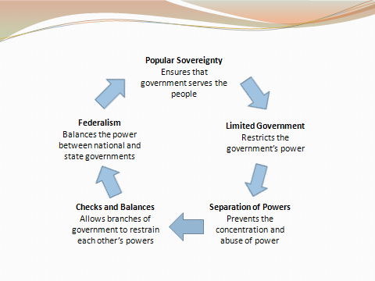

**Checks and Balances**

