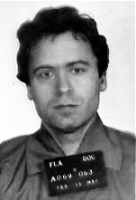
- Ted Bundy
Although serial killer Ted Bundy was responsible for an estimated 30-plus murders, there was little physical evidence to connect him to the crimes when he was arrested in 1975. Two years later, having been convicted only of kidnapping, Bundy was preparing to stand trial for murder in Colorado when he escaped and headed to Florida. There, he killed three more people early in 1978, and when he was finally captured in February of that year, the physical evidence in those cases led to his conviction. Most crucial was the matching of a bite mark on the buttock of victim Lisa Levy to the Bundy's distinctive, crooked and chipped teeth. He was convicted also of the murder of 12-year-old Kimberly Leach based on fibers found in his van that matched the girl's clothing. Bundy was put to death in 1989.

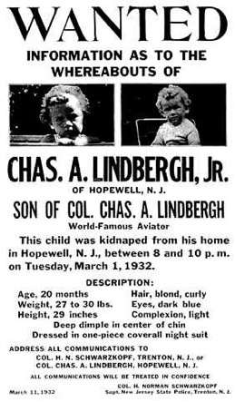
- The Lindbergh Kidnapping
On March 1, 1932, Charles Lindbergh Jr., the 20-month-old son of the famous aviator, was kidnapped, and although a ransom of $50,000 was paid, the child was never returned. His body was discovered in May just a few miles from his home. Tracking the circulation of the bills used in the ransom payment, authorities were led to Bruno Hauptmann, who was found with over $14,000 of the money in his garage. While Hauptmann claimed that the money belonged to a friend, key testimony from handwriting analysts matched his writing to that on the ransom notes. Additional forensic research connected the wood in Hauptmann's attic to the wood used in the make-shift ladder that the kidnappers built to reach the child's bedroom window. Hauptmann was convicted and executed in 1936.

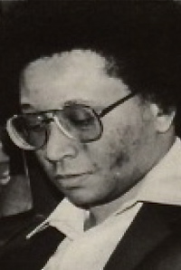
3. The Atlanta Child Murders
In a two year period between 1979 and 1981, 29 people -- almost all children -- were strangled by a serial killer. Police staked out a local river where other bodies had been dumped and arrested Wayne Williams as he was driving away from the sound of a splash in an area where a body was recovered a couple of days later. Police didn't witness him drop the body, so their case was based largely on forensic evidence gathered from fibers found on the victims. In all, there were nearly 30 types of fiber linked to items from Williams' house, his vehicles and even his dog. In 1982, he was convicted of killing two adult victims and sentenced to life in prison, although the Atlanta police announced that Williams was responsible for at least 22 of the child murders.

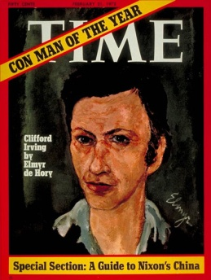
4. The Howard Hughes Hoax
In 1970, authors Clifford Irving and Richard Suskind concocted a scheme to forge an autobiography of notoriously eccentric and reclusive billionaire Howard Hughes. Assuming that Hughes would never come out from hiding to denounce the book, they felt that their plan was fool-proof. Irving went to publisher McGraw-Hill claiming that Hughes had approached him to write his life story and that he was willing to correspond with only the author. As proof, Irving produced forged letters that he claimed were from Hughes. McGraw-Hill agreed, paying $765,000 for the right to publish the book. When word of the book was made public, however, Hughes contacted reporters to denounce it as false. Not wishing to appear in public, the billionaire would talk to reporters only via telephone. Thus, a "spectographic voiceprint analysis," measuring tone, pitch and volume, was conducted to determine if the speaker was indeed Howard Hughes. Although a handwriting expert had previously been fooled by the notes that Irving had forged, the voice analyst correctly identified the speaker as Hughes. Irving was exposed and confessed before the book was published. He spent 17 months in prison, while Suskind spent five. Irving later wrote a book about the scheme, The Hoax, which became a major motion picture in 2008.

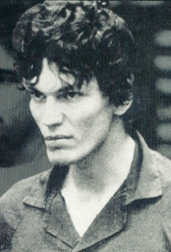
5. The Night Stalker
Between June 1984 and August 1985, a Southern California serial killer dubbed the Night Stalker broke into victims' houses as they slept and attacked, murdering 13 and assaulting numerous others. With citizens on high alert, an observant teenager noticed a suspicious vehicle driving through his neighborhood on the night of August 24, 1985. He wrote down the license plate and notified police. It just so happened that the Night Stalker's latest attack took place that night in that area, so police tracked down the car. It had been abandoned, but police found a key piece of evidence inside: a fingerprint. Using new computer system, investigators quickly matched the print to 25-year-old Richard Ramirez and plastered his image in the media. Within a week, Ramirez was recognized and captured by local citizens. He was sentenced to death and currently sits in prison on death row.

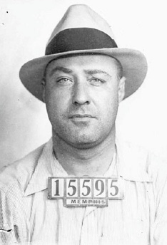
6. Machine Gun Kelly
George "Machine Gun" Kelly was a notorious criminal during the Prohibition era, taking part in bootlegging, kidnapping and armed robbery. On July 22, 1933, he and another man kidnapped wealthy Oklahoma City oilman Charles Urschel. After a series of ransom notes and communications, a $200,000 ransom was paid -- the largest amount ever paid in a kidnapping to date. Urschel was released nine days later, unharmed. The oilman had shrewdly paid close attention to every detail during his ordeal and was able to relate it all to police. Although he was blindfolded, he could tell day from night and was able to estimate the time of day that he heard airplanes fly above. He also noted the date and time of a thunderstorm and the types of animals he heard in what he presumed to be a farmhouse. Using his memories, the FBI pinpointed the likely location in which Urschel was held to a farm owned by Kelly's father-in-law. What truly linked Kelly and his gang to the kidnapping, though, was Urschel's fingerprints, which he made sure to place on as many items in the house as possible. Kelly was sentenced to life in prison, where he died in 1954.
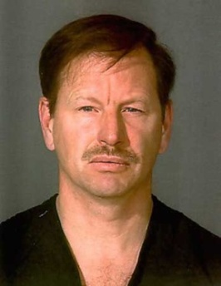
7. The Green River Killer
The Green River Killer was responsible for a rash of murders -- at least 48 but possibly close to 90 -- along the Green River in Washington state in the '80s and '90s. Most of the killings occurred in 1982-83, and the victims were almost all prostitutes. One of the suspects that police had identified as early as 1983 was Gary Ridgway, a man with a history of frequenting and abusing prostitutes. However, although they collected DNA samples from Ridgway in 1987, the technology available didn't allow them to connect him to the killings. It wasn't until 2001 that new DNA techniques spurred the reexamination of evidence that incriminated Ridgway. He was arrested and later confessed. Ridgway pleaded guilty to 48 murders -- later confessing to even more, which remain unconfirmed -- in exchange for being spared the death penalty. He was sentenced to 48 life sentences without the possibility of parole.

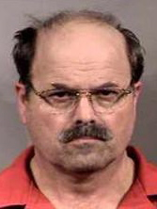
8. BTK Killer
The BTK ("Bind, Torture, Kill") Killer was a serial killer who terrorized the Wichita, Kansas area between 1974 and 1991, murdering 10 people over the span. The killer craved media attention and sent letters to local newspapers and TV stations, taunting investigators. It's this egotism that led to his capture, however. When he resurfaced in 2004 with a series of communications, he chose to send a computer floppy disk to the Wichita Eagle. Forensic analysts traced the deleted data on the disk to a man named Dennis at the Christ Lutheran Church in Wichita. It didn't take long for the police to arrest Dennis Rader, who confessed and was sentenced to nine life terms in prison.

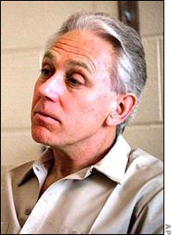
9. Jeffrey MacDonald
Early in the morning of February 17, 1970, the family of Army doctor Jeffrey MacDonald was attacked, leaving the doctor's pregnant wife and two young daughters dead from multiple stab wounds. MacDonald himself was injured by what he claimed to be four suspects, but he survived with only minor wounds. Doubt was immediately cast on the doctor's story, based on the physical evidence on the scene that suggested that he was the killer. However, the Army dropped the case because of the poor quality of the investigative techniques. Several years later, though, MacDonald was brought to trial in a civilian court. Key evidence was provided by a forensic scientist who testified that the doctor's pajama top, which he claimed to have used to ward off the killers, had 48 smooth, clean holes -- too smooth for such a volatile attack. Furthermore, the scientist noted that if the top was folded, the 48 holes could easily have been created by 21 thrusts -- the exact number of times that MacDonald's wife had been stabbed. The holes even matched the pattern of her wounds, suggesting that the pajama top had been laid on her before during the stabbing and not used in self-defense by the doctor. This crime scene reconstruction was crucial in MacDonald's conviction in 1979. He was sentenced to life in prison for the three murders.
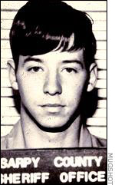
10. John Joubert
In 1983, two murders of schoolboys rocked the Omaha, Nebraska area. The body of one of the boys was found tied with a type of rope that investigators couldn't identify. While following up on the lead of a mysterious man scouting out a school, they traced the suspect's license plate to John Joubert, a radar technician at the local Air Force base. In his belongings, they found a rope matching the unusual one used in the murder (which turned out to be Korean). Although DNA analysis technology was not yet an option, the extreme rarity of the rope was enough to lead to Joubert's confession. Furthermore, hair from one of the victims was found in Joubert's car. The child killer was even linked to a third murder, in Maine, when his teeth were found to match bite marks on a boy killed in 1982. Joubert was found guilty of all three murders and was put to death in the electric chair in 1996.

